

Aggregation for purpose of analysis and plotting:

$$k_{f}=k_{1}+k_{3}+k_{5}$$

$$k_{b}=k_{2}+k_{4}+k_{6}$$

Error criterion: norm of weighted sum   
(weights are 1 for all components except for glycerine, where weight is set to 0)

$\left[z_{1,t} ,z_{2,t},…, z_{6,t}\right]$– experimentally measured concentrations of each of 6 components at time $t$ $[z_{1}\left(t\right), z_{2}\left(t\right),…,z_{6}\left(t\right)]$ 
 – solution of the kinetics model at time

1. L2 error
2. L0.5 error
$$ϵ_{L0.5}=\sum_{i=1}^{\begin{aligned}\#chemical \\ components\end{aligned}}{w_{i}⋅{\left(\sum_{j=1}^{\#obs}{\sqrt{z_{i}\left(t\right)-z_{i,t}}}\right)}^{2}}$$

3. Logarithmic error (for either L2 or L0.5)

Fit kinetics model

Optimizer

Is fit good enough?

Solve system of ODE

Check fit of a model

Normalized data

$x$, $y$, $z$

Start

$z\left(t\right)$, $x$, $y$

no

yes

$$k_{1},…,k_{6}$$

initial codition $z_{0}$

measurements $z_{1}, z_{2},…$

$$z(t)$$

$$\sum_{i}{\left|z_{i}-z\left(t_{i}\right)\right|}$$

Landscape of objective function with **norm L2**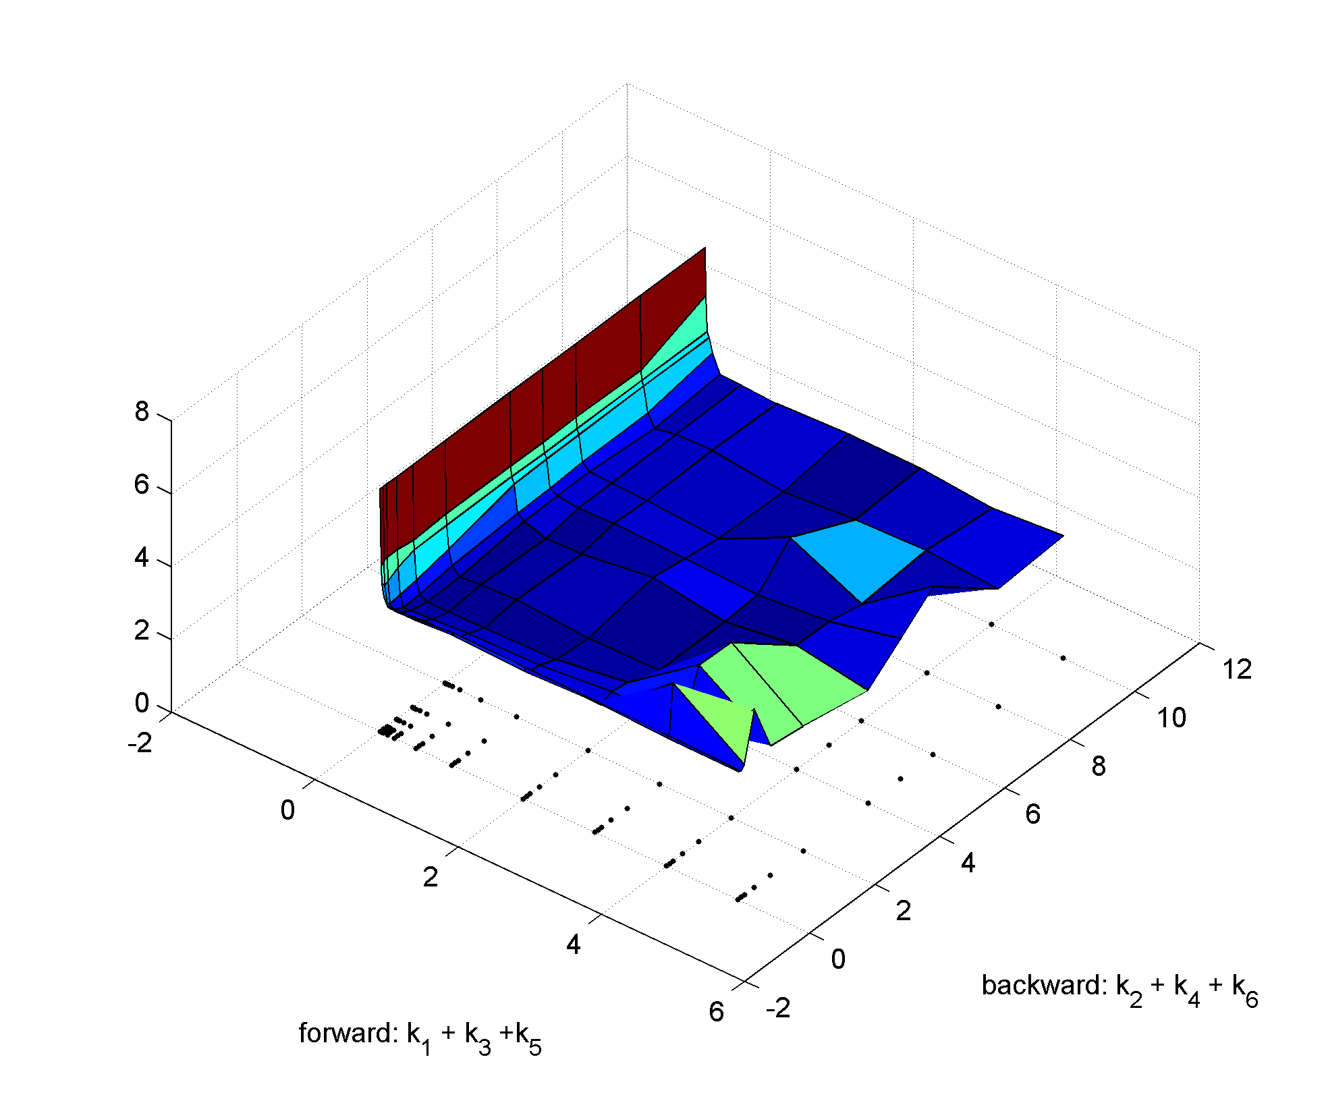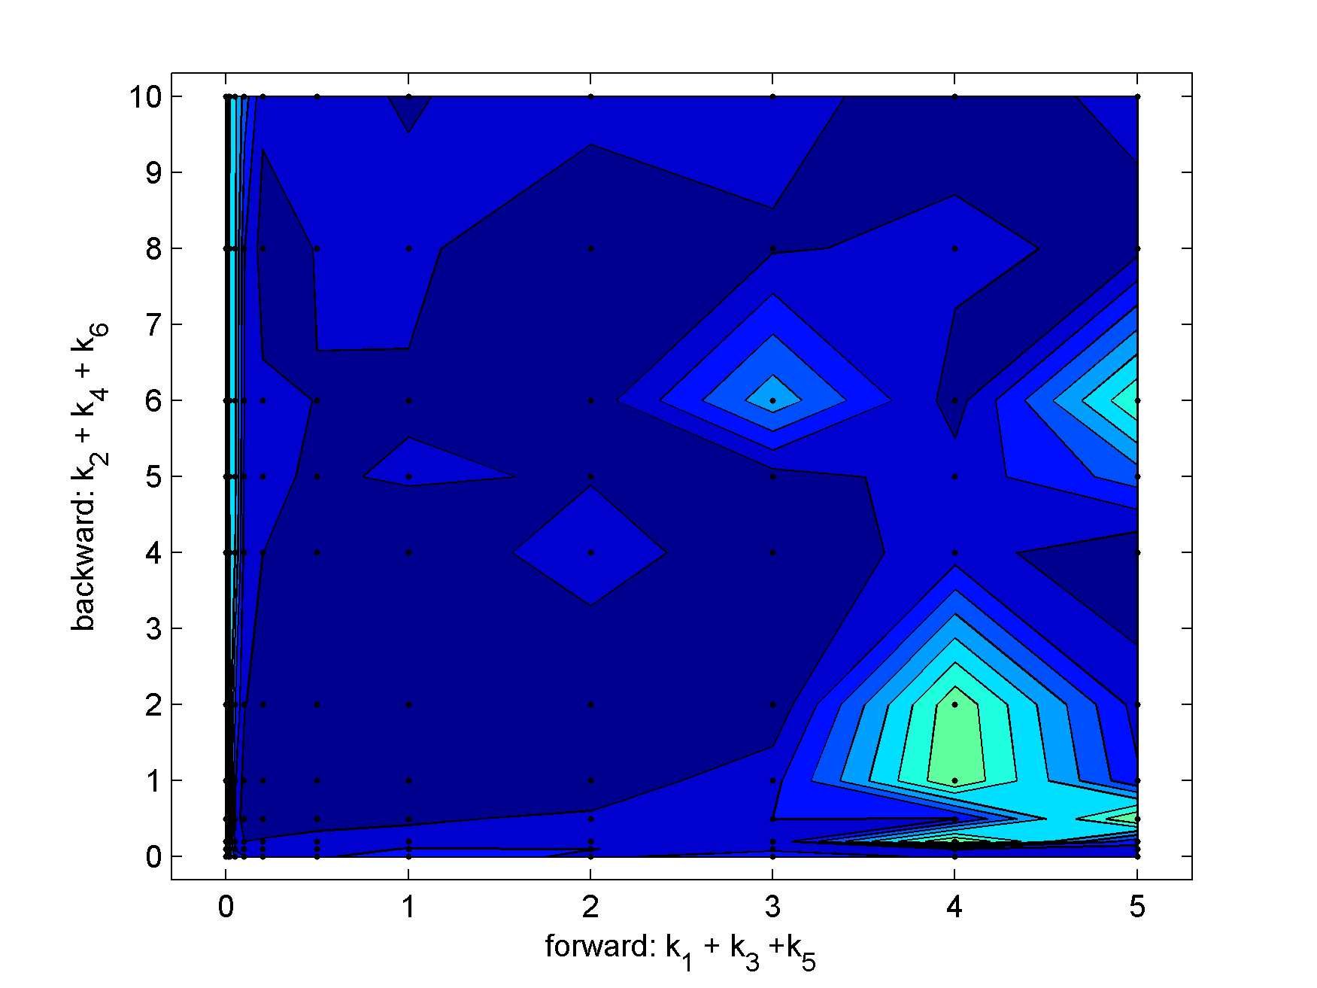

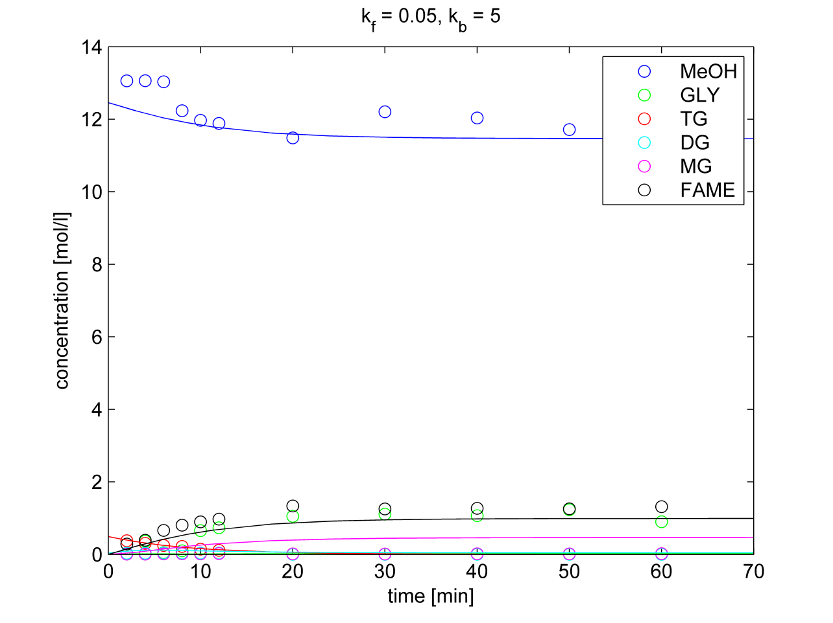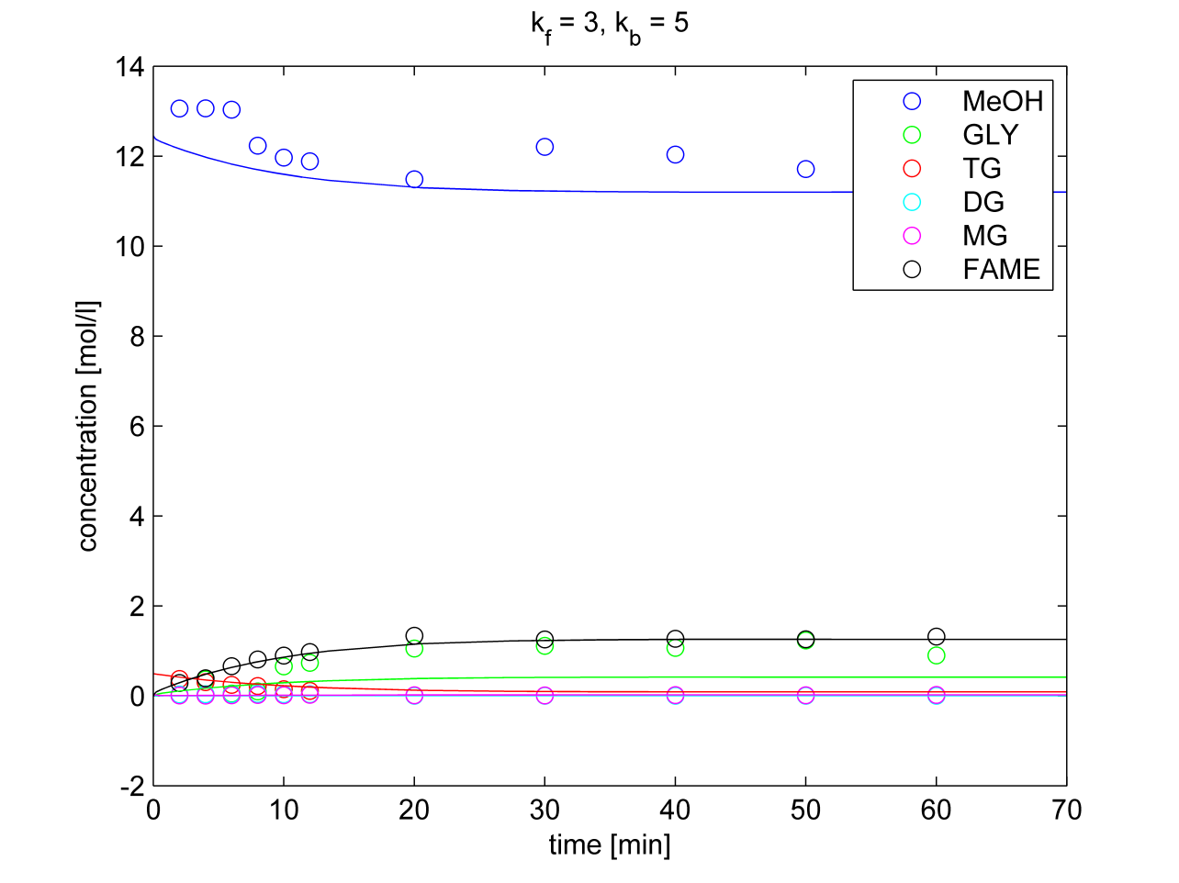

**Norm L0.5**

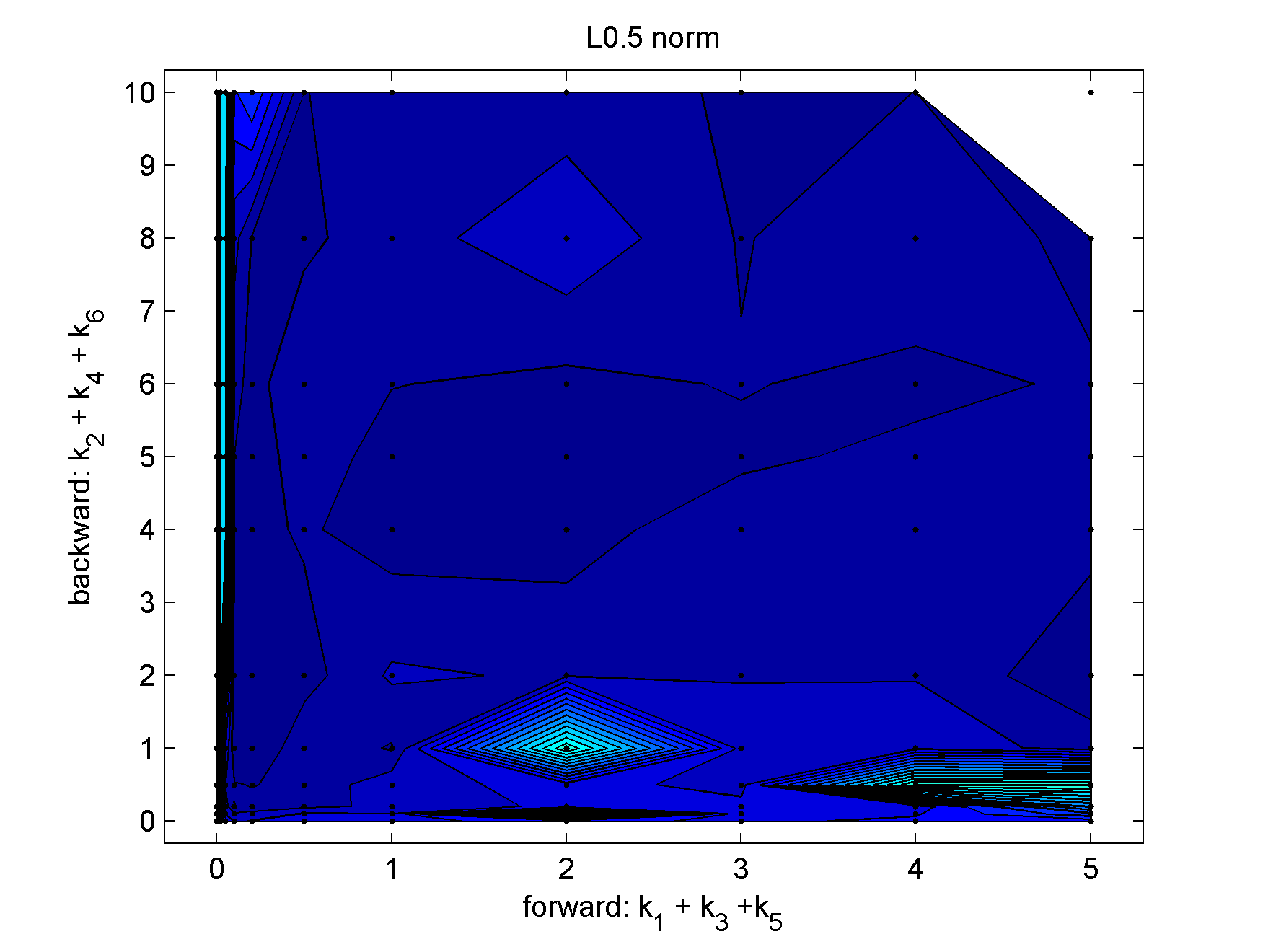

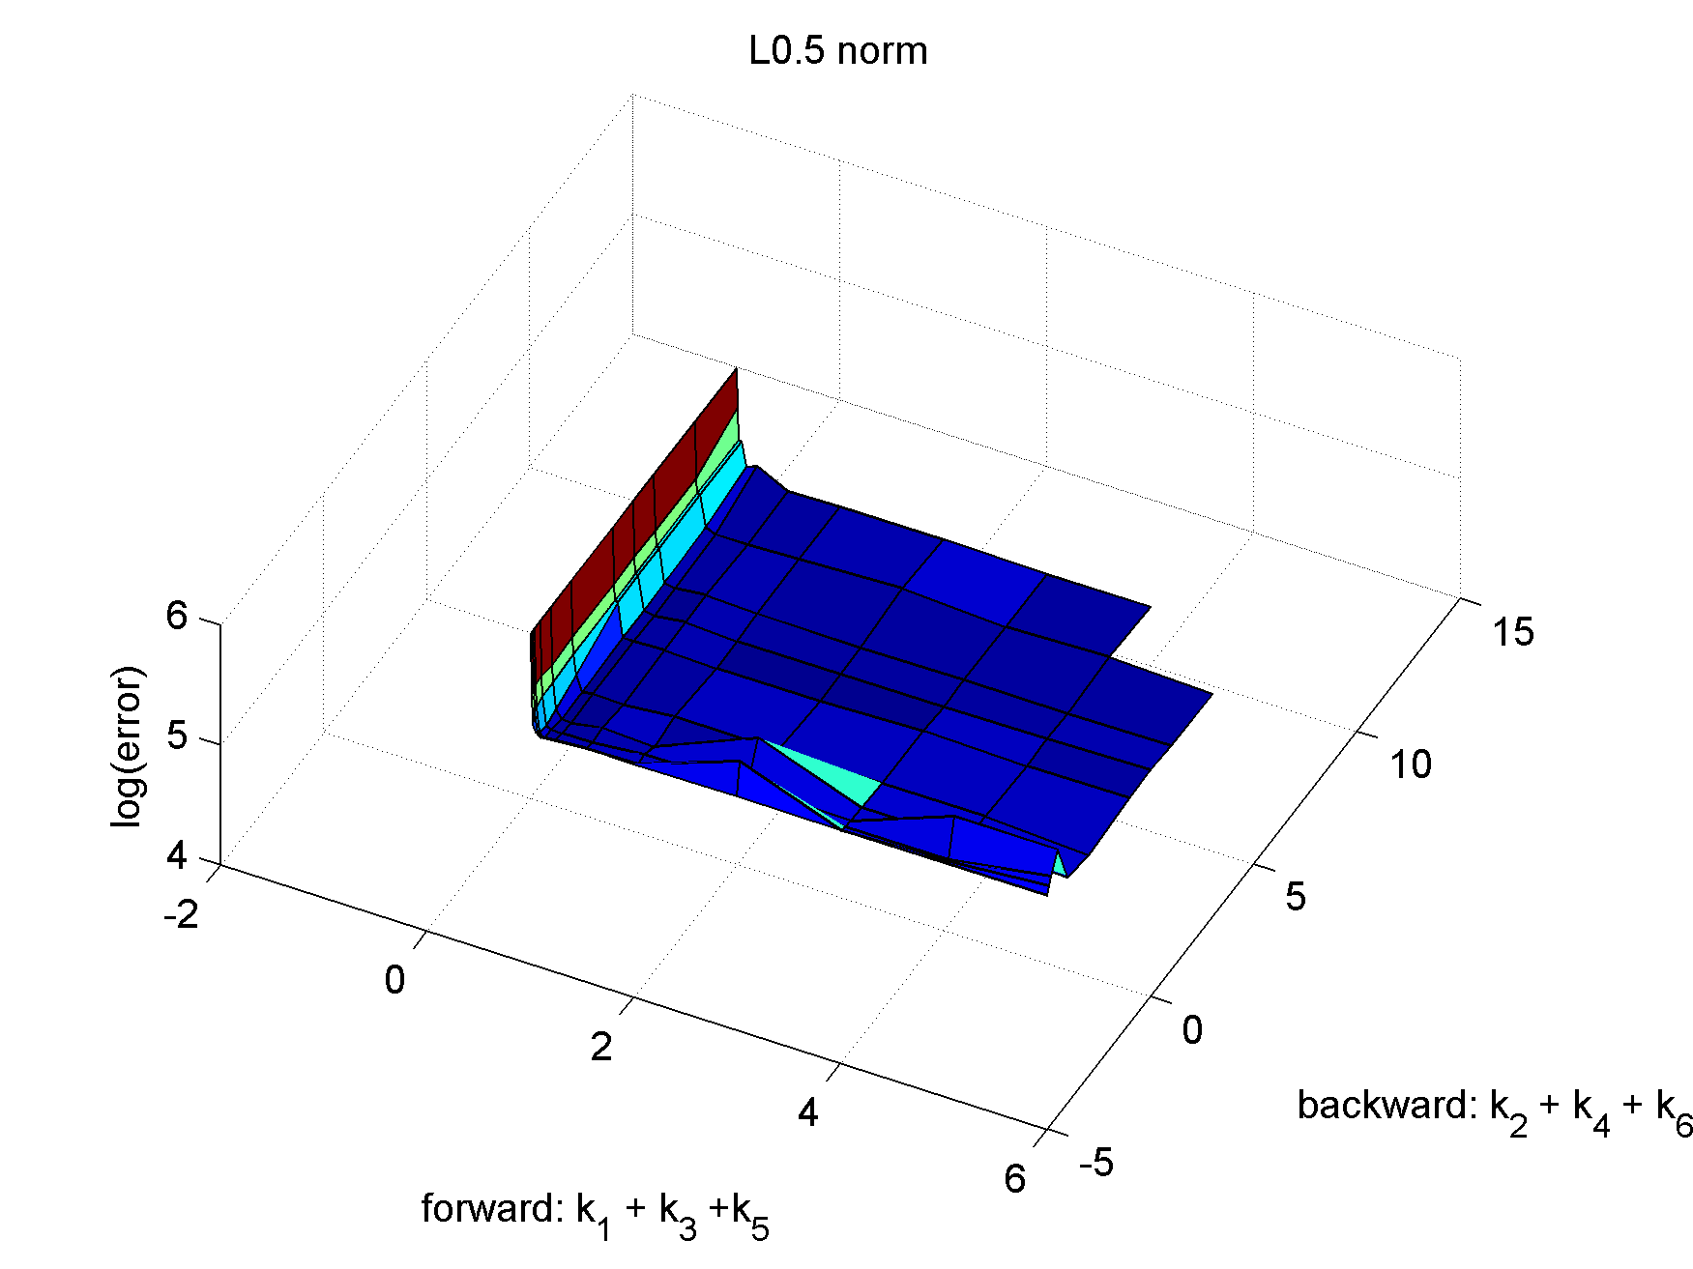

**Norms of logarithms $$k_{f}=0.35, k_{b}=1.1$$**  
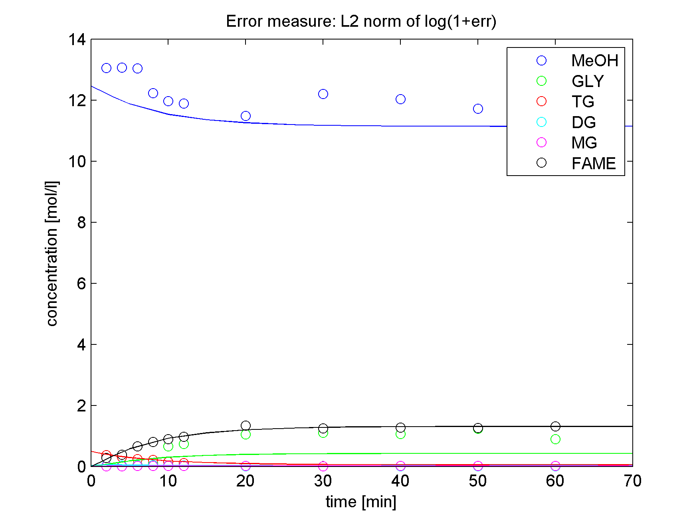

$$k_{f}=0.51, k_{b}=1.4$$

